**Ansible variables**

* <https://docs.ansible.com/ansible/latest/playbook_guide/playbooks_variables.html> for the official docs on variables
* changeset containing two variables one at inventory and other a playbook variable
* ref: <https://github.com/asquarezone/AnsibleZone/commit/5dc73ed81a9ab0344c9e2dc339dea322d4c00974?diff=split>

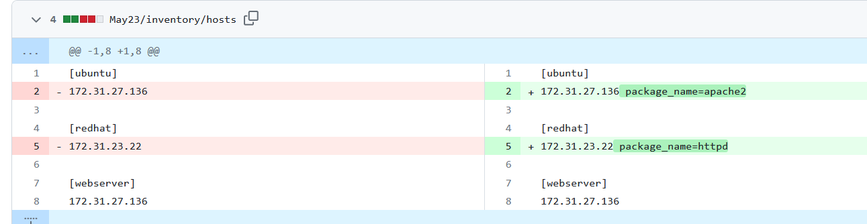

* Let’s use a generic package manager package <https://docs.ansible.com/ansible/latest/collections/ansible/builtin/package_module.html>
* <https://github.com/asquarezone/AnsibleZone/commit/0c57dfd0c607c4218e7949fdb320dac36fd64d98> for the changeset where we used package instead of apt/yum for install apache
* <https://docs.ansible.com/ansible/latest/playbook_guide/playbooks_loops.html> for loops in ansible
* <https://github.com/asquarezone/AnsibleZone/commit/ddbc2744d137b787fede1aabc2b04457c5057d8a> for the changeset with loops and using loops from variables
* variables at the inventory level need not be in inventory file
* <https://github.com/asquarezone/AnsibleZone/commit/b13c980476639382631c9da2b58d33ba0aecb8e4> for the changeset with host_vars and group_vars
* <https://github.com/asquarezone/AnsibleZone/commit/09903beb17d9da902a4061a118c111ea543826d5> for the changeset to fail playbook explicitly on unsupported os
* <https://github.com/asquarezone/AnsibleZone/commit/69f83641d3ef7aa43c103858947996ac7d047688> for the debug messages